18.5G NR Frame Structure Analysis with Different Subcarrier Spacing

1. AIM
To analyze the 5G NR frame structure for different subcarrier spacings (SCS) (15 kHz, 30 kHz, 60 kHz, 120 kHz) and observe how slot duration and number of slots per frame change using MATLAB.

2. SOFTWARE REQUIRED
- MATLAB (R2018 or later)
No toolbox required.

3. THEORY (Simple)
5G NR Numerology
5G uses scalable SCS defined as:
$$Δf=15×2^{μ}\text{ kHz}$$
where μ = 0,1,2,3…
μ | SCS (kHz) | Slot Duration (ms)
0 | 15 | 1.0
1 | 30 | 0.5
2 | 60 | 0.25
3 | 120 | 0.125
Frame Structure
- 1 frame = 10 ms
- Each frame has 10 subframes (each 1 ms)
- Slots per subframe depend on SCS:
$$\text{Slots per subframe}=2^{μ} \\ \text{Slots per frame}=10×2^{μ}$$
Higher SCS → more slots → lower slot duration → low latency.

4. PROCEDURE (Simple)
- Define SCS values: 15, 30, 60, 120 kHz.
- Compute μ from the SCS.
- Calculate slot duration = 1ms / (2^μ).
- Calculate number of slots per frame = 10 × (2^μ).
- Display results in a table.
- Plot SCS vs slot duration.

5. PSEUDOCODE
Define SCS list
For each SCS:
compute μ from log2(SCS/15)
compute slotDuration = 1ms / 2^μ
compute slotsPerFrame = 10 * 2^μ
Print results
Plot slotDuration vs SCS

CODE:
clear; clc; close all;
% Subcarrier Spacing values (kHz)
SCS_list = [15 30 60 120];
% FFT size and sampling frequency (assumed)
Nfft = 1024;
fs = 15e3 * Nfft; % Base sampling freq for 15 kHz SCS
symbol_duration = zeros(1,length(SCS_list));
for i = 1:length(SCS_list)
scs = SCS_list(i)*1e3; % convert kHz to Hz
Ts = 1/scs; % basic time unit
% OFDM symbol duration (approx)
T_sym = Nfft / (scs*Nfft); % = 1/scs
symbol_duration(i) = T_sym;
fprintf('SCS = %d kHz -> OFDM Symbol Duration = %.5f ms\n', ...
SCS_list(i), T_sym*1000);
end
% Plotting
figure;
plot(SCS_list, symbol_duration*1000, '-o', 'LineWidth', 2);
xlabel('Subcarrier Spacing (kHz)');
ylabel('OFDM Symbol Duration (ms)');
title('5G NR: Effect of Subcarrier Spacing on Symbol Duration');
grid on;
OUTPUT:RE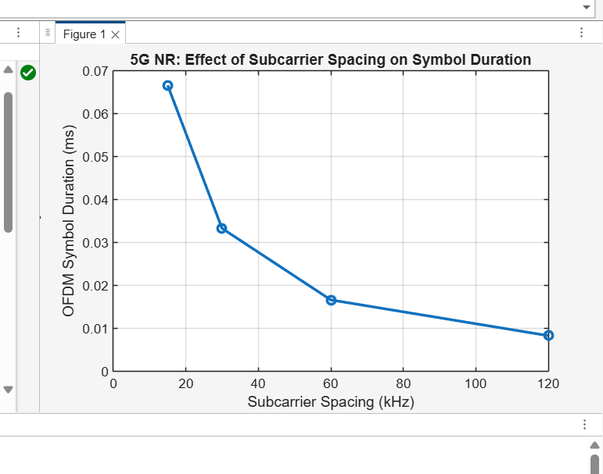

RESULT:
- Slot duration decreases as subcarrier spacing increases.
- Number of slots per frame increases with SCS.
- 15 kHz → lowest slot density (10 slots/frame).
- 120 kHz → highest slot density (80 slots/frame).
- Higher SCS supports low-latency 5G applications such as URLLC and mmWave.

